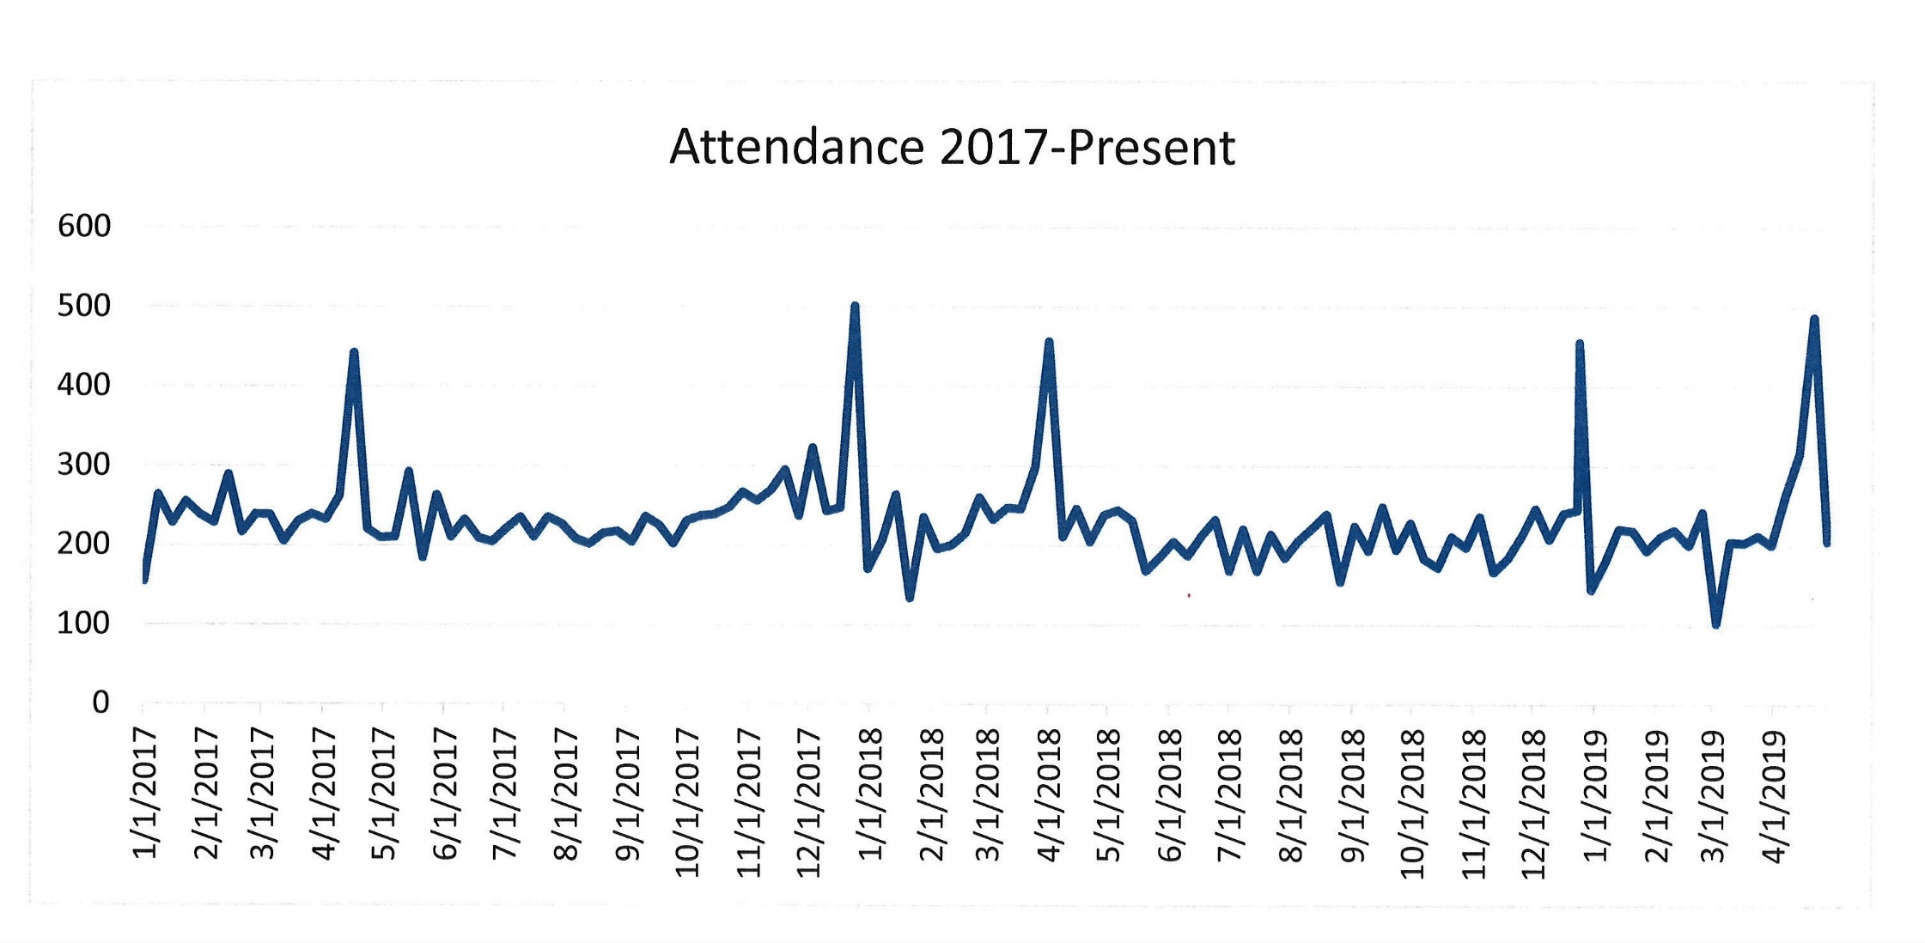

**Conversations with   
Call Committee -   
Myth Buster #2**

**Myth:**  Attendance at Holy Shepherd is declining

**Truth:** Looking at weekly attendance from 1/1/17 to present, our attendance is holding steady around 200 people per week.